- Articulation of Hypothesis:
Machine learning (ML) can detect hip labral tears on plain magnetic resonance imaging (MRI) in adult patients with symptomatic femoroacetabular impingement (FAI).
- Operationalization of Constructs (X, Y, P)
X – The purported causative agent:
Artificial intelligence (AI) will implement deep learning (DL) models with a convolutional neural network (CNN) to accurately detect labral tears on plain hip MRIs from a 1.5Tesla GE scanner in comparison to the gold standard magnetic resonance arthrogram (MRA). The tasks of the DL are detection, segmentation, and classification(1). The first algorithm is detection, which will focus on anatomic landmarks of the hip joint. The second is segmentation to identify the area of interest, the labrum. Lastly, is classification to describe morphologic characteristics of the labrum.
Y –The outcome:
Detection
Y – Capable to effectively detect landmarks.
Y1 – Presence of anatomic variants can lead to errors.
Segmentation
Y – Identify labral tissue with efficiency.
Y1 – Calcification/ossification within the labrum can affect interpretation.
Classification
Y – 1) Normal
Y – 2) Partial tear
  - +/- paralabral cyst
  - +/- chondral lesion
Y – 3) Full-thickness tear
- +/- paralabral cyst
- +/- chondral lesion
Y1 – Presence of artifact leading to a false positive.

P –The sample:
Our study population includes patients presenting with the onset of painful hip motion from activity consistent with (FAI) and persisted for a minimum of 6 weeks and a trial of conservative management (activity modification, rest). The patients then underwent MRI or MRA to rule out a labral tear.
Inclusion criteria:
- male or female patient
- activity related hip pain
- positive impingement test
- Alpha angle greater than 55 degrees on Dunn view radiograph and/or positive cross over sign on AP pelvis radiograph.
- ages 18 to 65
- MRI or MRA interpreted by a musculoskeletal board-certified radiologist at the same facility
- MRI or MRA from a 1.5Tesla GE scanner
Exclusion criteria:
- <18 years of age; >/=66 years of age
- Associated lumbar spine symptoms
- prior hip surgery
- history of Perthes
- SCFE
- avascular necrosis
- Tonnis Grade >1 on radiographs.
Cohort 1: Patients with documented labral tears on plain hip MRIs confirmed on Magnetic Resonance Arthrogram (MRA) by the musculoskeletal radiologist.
Cohort 2 (control): Patients with no evidence of hip labral tear on both MRI and MRA.

- Study Design Capable of Addressing Hypothesis
The study is a retrospective longitudinal analysis of plain hip MRI using AI to detect hip labral tears compared to the gold standard currently used to detect hip labral tears, MRA. The negative control will be hip MRIs without labral tear pathology on both plain MRI and MRA.
The performance of the hybrid supervised DL model is in two phases: training and testing. The training phase will focus on identifying normal hip labrum versus hip labral tears. The testing phase will compare the DL model to the imaging interpretation by the musculoskeletal radiologist.

Below is a Figure of the Training samples we plan to implement for our study:
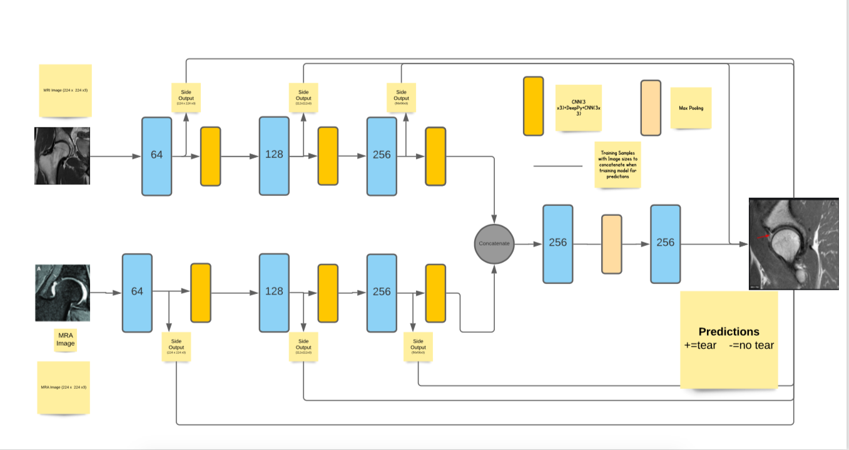

In the figure above, we will work under the following assumptions from a DL perspective to assess the feasibility of the study from the data to support the hypothesis:
- The images we plan to train on will be done on a 2D/3D plane with a 256 x 256 pixel to support the predictions of a labral hip tear or no labral hip tear
- To confirm our prediction, we will train our model on a small sample size of n=200 and provide an output file of ROC and AUC to assess the predictions from the two cohorts.
2X2 contingency tables will be utilized to detect the sensitivity and specificity of AI detecting labral tears on MRI in comparison to MRA:

Positive Predictive Value (PPV) = True Positive (TP)
True Positive (TP) + False Positive (FP)

Negative Predictive Value (NPV) = True Negative (TN)
True Negative (TN) + False Negative (FN)

AI Interpretation | MRA positive labral tear | MRA negative labral tear
Positive labral tear | TP | FP
Negative labral tear | FN | TN

4. Power Analysis (THIS SECTION)

4.1. Describe the “effect size” you believe to be clinically important, and why you believe it will be likely / feasible that you will produce / observe such an effect, or describe the sample size limitations and where the “detectable” effect size lives relative to the clinically important one.

EXAMPLE
0.4% difference or greater in A1C is believed to be clinically important, based on threshold for non-inferiority from type 1 diabetes drug trials (INSTRIDE 1 Phase 3 study: efficacy and safety of MYL-1501D vs insulin glargine in patients with type 1 diabetes after 52 weeks: https://www.ncbi.nlm.nih.gov/pubmed/29656504). Given that approximately 25 million Americans have type 1 diabetes and that the study is observational in nature, we believe it is likely that we can recruit a sufficient number of patients to observe a clinically meaningful difference in A1C based on insurance type.
- 4.2. State the conditions under which you performed your sample size / effect size calculation (i.e. describe your numeric choices of the ingredients)
EXAMPLE
We estimate a necessary sample size of 368 patients (184 patients per group) based on the following assumptions:
o Type 1 Error of 5% (i.e., 5% alpha)
o Type 2 Error of 20% (i.e., 80% power)
o 1:1 ratio of HDHP vs. traditional insurance patients
o Standard deviation of A1C within each group of 1.3% (approx. 1.5x the
standard deviation in A1C of patients enrolled in INSTRIDE 1 study to account for higher expected variance in A1C in a real-world setting vs. a controlled randomized clinical trial)
o Hypothetical clinically meaningful difference in A1C of 0.4% between groups
o 10% dropout rate (approx. 1.5x the 7% dropout rate of patients enrolled in INSTRIDE 1 study to account for higher expected dropout in a real-world setting vs. a controlled randomized clinical trial)
Sample size was estimated assuming an independent t-test design using the Vanderbilt University Department of Biostatistics Power and Sample Size program (https://statcomp2.app.vumc.org/ps/).
4.3. Summarize
EXAMPLE
To observe a 0.4% difference in mean A1C between groups with an alpha of
0.05, 80% power, and 10% dropout rate, we estimate a necessary sample size of 368 patients (184 patients per group).

5. Measures and Data Collection Plan
DATA COLLECTION LOG:

Construct / Indicator | SOURCE | MECHANSIM | FREQUENCY | RESPONSIBLE PERSON | WHERE Continuous or HOUSED Discrete |  | How will Rel /Validity be assessed
X – ML MRI read on symptomatic FAI |  |  |  |  | REDCap | Discrete
Y0 – FAI history/exam | Patient chart | Electronic chart abstraction | One time, follow up visit | Hip specialist (HS)  Office staff | REDCap | Discrete | Data will be reviewed by independent HS
Y1 – Digital Hip Series Xrays  (Weight bearing AP pelvis, False profile, Dunn view) | Imaging Centers  Institutions | Upload digital xrays onto Weill Cornell Ambra  Digitally measured alpha angle | One time | 1) Research assistant (RA) (upload imaging onto Ambra)  2) HS interpretation of radiographs. | REDCap | Discrete | X-ray interpretation by independent HS.
Y2 – MRI | East River Imaging (ERI) | Upload MRI onto Weill Cornell Ambra | One time | Health care provider (HCP)  HS  RA (upload imaging onto Ambra)  Two Musculoskeletal radiologists (MSK R) will interpret MRI | REDCap | Discrete | Independent MSK R will interpret MRI.  Interrater reliability  Intrarater reliability
Y3 - MRA |  |  | One time | HCP  HS  RA (upload imaging onto Ambra)  Two Musculoskeletal radiologists (MSK R) will interpret MRA | REDCap | Discrete | Independent MSK R will interpret MRA  Interrater reliability  Intrarater reliability
  ERI | Upload MRI onto Weill Cornell Ambra
  Upload MRA onto Weill Cornell Ambra | Upload MRI onto Weill Cornell Ambra
X2 - Age | Patient chart | Electronic chart abstraction | Once after enrollment | Office staff | REDCap | Discrete | Data will be reviewed by RA to assess age as predictor with regression analysis.
X3 – Sex | Patient chart | Electronic chart  abstraction | Once after enrollment | Office staff | REDCap | Discrete | Data will be reviewed by RA to assess sex as predictor with regression analysis
X4 – BMI | Patient chart | Electronic chart  abstraction | Once after enrollment | Office staff | REDCap | Discrete | Data will be reviewed by RA to assess sex as predictor with regression analysis

Reference
- Wang VM et al. Machine learning Applications in Orthopedic Imaging. JAAOS, May 2020, Vol 28, e415.

